# Installation/backup instructions

## Part 1 Installation

### Access

1. Check the path to the shared file and copy the file (1. IMS V07.accdb) to the desired location.
2. Double-click the file (1. IMS V07.accdb) to launch Access, and the database will be connected to the appropriate database and available for use with the forms and reports you want to use.
3. Enable Content if prompted  
   
4. If you don't see the linked tables, you need to reconfigure the network settings. So, let's work on connecting to the database. First, click [External Data]->[New Data Source]->[From Database]->[From SQL Server].  
   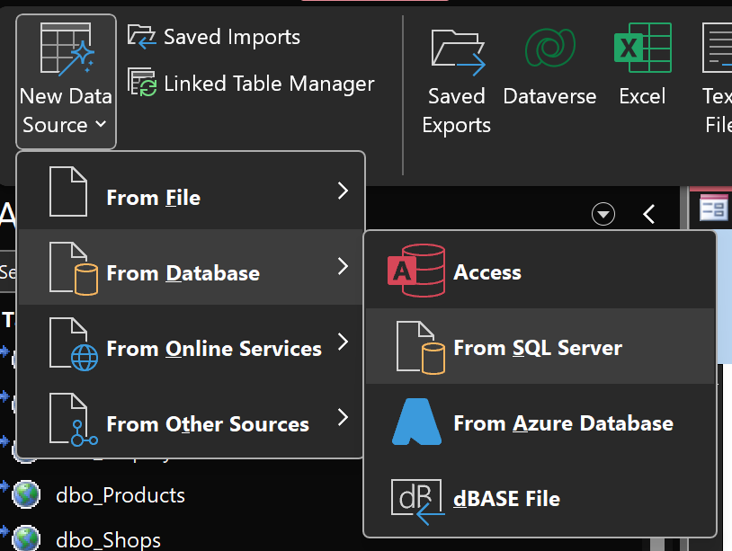
5. Select [Link to the data source by creating a linked file] and Click [OK]  
   A screenshot of a computer

   Description automatically generated
6. Click [New] button  
   A screenshot of a computer

   Description automatically generated
7. Select ODBC Driver 1x for SQL Server and Click [Next]  
   A screenshot of a computer

   Description automatically generated
8. Click [Browse] button  
   A screenshot of a computer

   Description automatically generated
9. Type [Assignment01] in File name and click [Save]  
   A screenshot of a computer

   Description automatically generated
10. Check the information and Click [Finish]  
    A screenshot of a computer

    Description automatically generated
11. Type in [localhost] in Server name  
    A screenshot of a computer

    Description automatically generated
12. Select [With SQL Server authentication using…] and fill the account information  
    A screenshot of a computer

    Description automatically generated
13. Checked [Change the default database to:] and select [Assigment01] Database than click [Next]  
    A screenshot of a computer

    Description automatically generated
14. Check all the information and click [Finish]  
    A screenshot of a computer

    Description automatically generated
15. Click [OK] button  
    A screenshot of a computer

    Description automatically generated
16. Select Assignment01.dsn and click [OK]  
    A screenshot of a computer

    Description automatically generated
17. Login SQL Server by user id and password  
    A screenshot of a computer

    Description automatically generated
18. Select all the required tables and click OK.  
    A screenshot of a computer

    Description automatically generated

### MSSQL

1. Run SQL Server Management Studio and log in as Administrator.
2. Right-click the [localhost] -> [Database] item in the Object Explorer tree to call the pop-up menu, and select the [Restore Database] menu.   
   A screenshot of a computer

   Description automatically generated
3. In the pop-up window, select [Device] -> [...] from [Source].   
   A screenshot of a computer

   Description automatically generated
4. Click [Add] button to select the correct path and file, and click [OK] button to load the file.  
   A screenshot of a computer

   Description automatically generated
5. When the file name and path are confirmed, click [OK] button.   
   A screenshot of a computer

   Description automatically generated
6. The backup file has been successfully restored.  
   A screenshot of a computer

   Description automatically generated
7. Check the restored database in [Object Explorer]->[Databases].   
   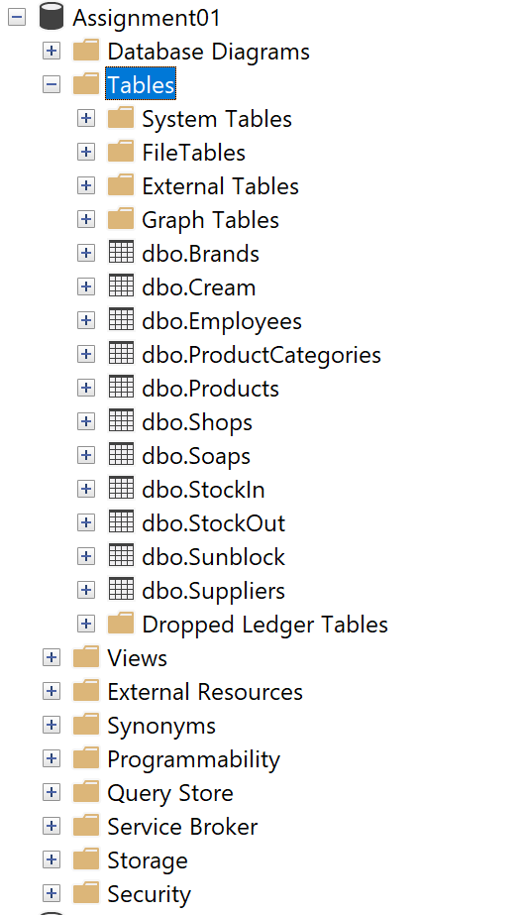

8. Open the query screen to change database user permissions.

9. Change the query by replacing ‘User001’ to your user name instead and run the query.

## Part 2 Backup

### Access

1. Save the access file.
2. Copy the file to a directory for backup, etc.
3. Change the file name after copying.

### MSSQL

1. Right-click on [Object Explorer] -> [Databases] -> [Assignment 1] to call the menu and select [Tasks] -> [Back Up].   
   A screenshot of a computer

   Description automatically generated
2. In the [Source] item, check the name of [Database] and press [Add] button  
   A screenshot of a computer

   Description automatically generated
3. Click the [...] button to show the possible directory path to save the restore backup file.   
   A screenshot of a computer

   Description automatically generated
4. Decide the directory and file name to backup and click [OK] button. Backup folder under MSSQL directory is ok.  
   A screenshot of a computer

   Description automatically generated
5. Confirm the directory and file name to be backed up and click the [OK] button.  
   A screenshot of a computer

   Description automatically generated
6. The backup of the database is completed.  
   A screenshot of a computer

   Description automatically generated